**INSTITUTIONAL PROGRAM REVIEW 2009-10**

**Program Efficacy Phase, Spring, 2010**

**Purpose of Institutional Program Review**

Welcome to the Program Efficacy phase of the San Bernardino Valley College Program Review process.  Program Review is a systematic process for evaluating programs and services annually.  The major goal of the Program Review Committee is to evaluate the effectiveness of programs, and to make informed decisions about budget and other campus priorities.

The Institutional Program Review Committee is authorized by the Academic Senate to develop and monitor the college Program Review process, receive unit plans, utilize assessments as needed to evaluate programs, recommend program status to the college president, identify the need for faculty and instructional equipment, and interface with other college committees to ensure institutional priorities are met.

The purpose of Program Review is to:

❑  Provide a full examination of how effectively programs and services are meeting departmental, divisional, and institutional goals

❑  Aid in short-range planning and decision-making

❑  Improve performance, services, and programs

❑  Contribute to long-range planning

❑  Contribute information and recommendations to other college processes, as appropriate

❑  Serve as the campus’ conduit for decision-making by forwarding information to or requesting information from appropriate committees

Our Program Review process is two-fold.  It includes an annual campus-wide needs assessment in the fall, and an in-depth review of each program every three years that we call the Program Efficacy phase.  Instructional programs are evaluated the year after content review, and every three years thereafter, and other programs are placed on a three-year cycle by the appropriate Vice President.

An efficacy team of two disinterested committee members will meeting with you to carefully review and discuss your document.  You will receive detailed feedback regarding the degree to which your program is perceived to meet institutional goals.  The rubric that the team will use to evaluate your program is included with this e-mail

When you are writing your program evaluation, you may contact efficacy team assigned to review your department or your division representatives for feedback and input.  The list of readers is being sent to you with these forms as a separate attachment.

Forms are due back to the Committee Chairs, Efficacy Team and Division Dean by March 22, 2010.

It is the writer’s responsibility to be sure the Committee receives the forms on time.

In response to campus wide feedback that program review be a more interactive process, the committee will pilot a program efficacy that includes a review team who will interviews and/or tour a program area during the efficacy process. Another campus concern focused on the duplication of information required for campus reports. The pilot will incorporate the Educational Master Plan One-Page Summary (EMP Summary) and strive to reduce duplication of information while maintaining a high quality efficacy process. More details on the pilot can be found in the attached file.

**Program Efficacy, Spring 2010**

Complete and attach this cover sheet as the first page of your report.

**Program Being Evaluated**

|  |
| --- |
| Warehouse |

**Name of Department:**

|  |
| --- |
| Warehouse |

**Name of Division**

|  |
| --- |
| Applied Technology and Culinary Arts |

**Name of Person Preparing this Report                                                  Extension**

Kevin Kammer

**Name of Department Members Consulted**

|  |
| --- |
| Amanda Moody, Catherine Francis, Mark Hedges |

**Name of Efficacy Team**

|  |
| --- |
| Maha Al-Husseini Ext 8248; Troy Sheffield Ext 8585 |

**Program Review Committee Representatives**

|  |
| --- |
| Guy Hinrichs; Richard Jaramillo |

|  |  |  |
| --- | --- | --- |
| **Work Flow** | **Due Date** | **Date Submitted** |
| 3/4/2010 | April 1, 2010 | April 1, 2010 |
| Final draft sent to the dean | Click here to enter text. | April 1, 2010 |
| Report submitted to Program Review Team | Click here to enter text. | Click here to enter text. |
| Meeting with Review Team | Click here to enter text. | Click here to enter text. |

**Staffing**

List the number of full and part-time employees in your area.

|  |  |  |  |
| --- | --- | --- | --- |
| **Classification** | **Number Full-Time** | **Number Part-time, Contract** | **Number adjunct, short-term, hourly** |
| Managers | Click here to enter text. | Click here to enter text. | Click here to enter text. |
| Faculty | Click here to enter text. |  | 2 |
| Classified Staff | 1 | Click here to enter text. | Click here to enter text. |
| **Total** | 1 | 2 | 2 |

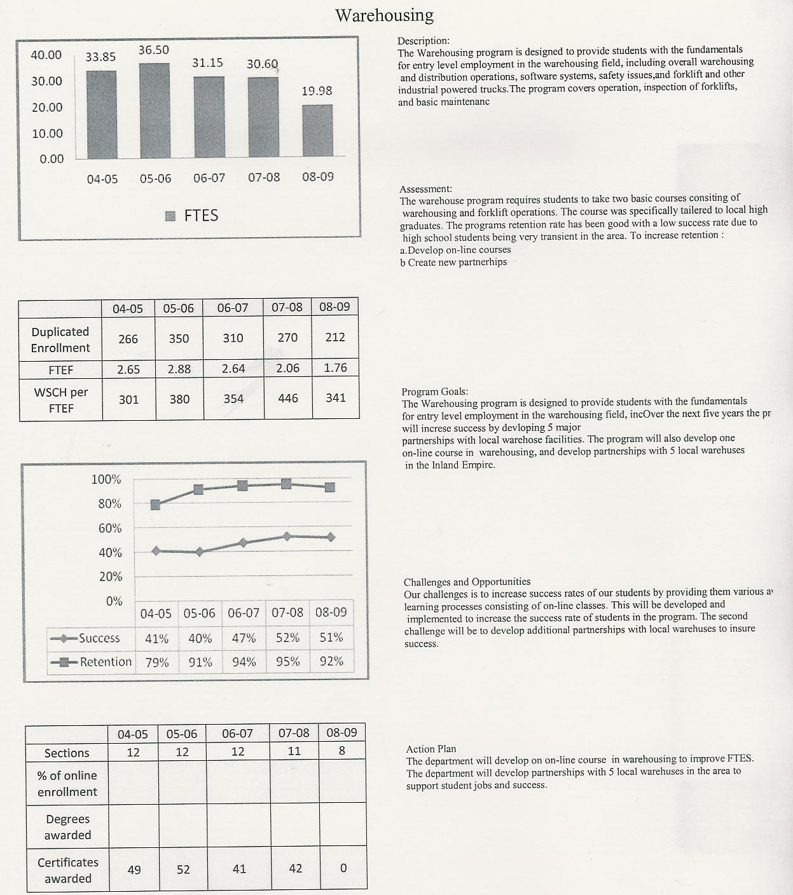

**Part I.  Questions Related to Strategic Initiative: Access**

**Warehouse**

**2008 – 2009**

|  |  |  |  |
| --- | --- | --- | --- |
| **Gender** | **Frequency** | **Dept. Percent** | **Campus Pct.** |
| Female | 102 | 22.3 | 55.71% |
| Male | 348 | 76.0 | 100.0 |
| Total | 458 | * | * |

|  |  |  |  |
| --- | --- | --- | --- |
| **Ethnicity** | **Frequency** | **Dept. Percent** | **Campus Pct.** |
| Asian | 8 | 1.7 | 4.42% |
| Black | 134 | 29.3 | 20.50% |
| Filipino | 6 | 1.3 | 1.84% |
| Hispanic | 189 | 41.3 | 42.90% |
| Nat Amer | 3 | .7 | .93% |
| Other | 5 | 1.1 | .95% |
| Pac Islander | 4 | .9 | .72% |
| White | 86 | 18.8 | 22.48% |
| X-undeclared | 12 | 2.6 | 5.26% |
| Total | 458 | * | * |

|  |  |  |  |
| --- | --- | --- | --- |
| **Disability** | **Frequency** | **Dept. Percent** | **Campus Pct.** |
| Non-Disabled | 431 | 94.1% | 95.5% |
| Disabled | 27 | 5.9% | 4.5% |
| Total | 458 | 100.0 |  |

Use the demographic data provided to describe how well you are providing access to your program by answering the questions below.

Click here to enter text.

Does the program population reflect the college’s population?  Is this an issue of concern?  If not, why not? If so, what steps are you taking to address the issue?

|  |
| --- |
| We serve a broad cross section of the Region’s population including the homeless, high school juniors and seniors, the unemployed and under-employed, individuals looking to advance their careers or develop a stable career, economically established individuals looking to stay current with technological changes, small business owners, entrepreneurs and others. Age groups are from under eighteen to retirees. The program which serves 76% males is serving more females than other technical programs that serve only 10% female students. There is a 10% difference in department to Campus percentage in the black ethnic population with the department serving more than the Campus percentage and there is a 3.5% imbalance serving less than the campus in the white ethnic area. There are more disabled students in the program than campus wide. This difference may be attributed to a perception of the program and the industry it serves by certain ethnic groups. We are not concerned about the differences in ethnicity and we are taking substantial steps to recruit females and ensure that group is fully aware of equal opportunities in the industry. Our primary method is our marketing materials that depict females at work in the industry. |

**Pattern of Service**

How does the pattern of service and/or instruction provided by your department serve the needs of the community? Include as appropriate hours of operation/pattern of scheduling, alternate delivery methods, weekend instruction/service.

|  |
| --- |
| Class scheduling is designed to accommodate the largest number of students by scheduling morning and late afternoon classes. This has realized the greatest opportunities for enrollment as this industry operates 24 hours a day 7 days a week We also offer a short term and full semester classes in the warehouse technology |

**Part II: Questions Related to Strategic Initiative: Student Success**

Provide a brief analysis of the data and narrative from the program’s EMP Summary and discuss what it reveals about your program.

|  |
| --- |
| Student success in the warehouse dept. has steadily increased from a 41% to 51% over the last 4 years with a peak and slight dip in 08-09. By developing on line classes and encouraging students with leaning problems to seek additional tutoring student success can be increased. Retention is very high as compared to other programs on the campus with a increase of 13% from 04-05 to 08-09 with a peak and slight dip in 07-08. The dip is due to a cohort of High School students who we feel were not adequately prepared for college level course work. We do not have hard numbers on placement however based on student feed back we believe 30% of successful completers are obtaining what we consider to be ideal employment in logistics at a rate of $11 or more per hour. Another 30% of successful completers according to Datatel are moving on to take more classes at Valley College after their experience with the warehousing program. The department considers pursuit of continuing education just as much a success as obtaining entry level logistics employment. Certificates awarded have been fairly constant from 04-05 with 49, and a peak of 52 and then a slight dip to 42. These are certificates that are awarded by the institution and do not reflect certificates completed by the student and awarded by the faculty. The number of certificates awarded by the faculty is approximately 60 per year. . |

**Supplemental Data**

Provide any additional information such as job market indicators, standards in the field or licensure rates that would help the committee to better understand how your program contributes to the success of your students.

|  |
| --- |
| The Warehouse program must maintain compliance with CalOSHA regulations, specifically in regards to the Forklift Operation and Certification programs.  The numbers for Certificates are stated as certificate eligibility over the past 3 years equals 165 per Datatel grade.  A report from Kevin Fleming from the Center of Excellence (COE) SBCCD states that the occupational cluster of transportation and warehouse related occupations has a projected growth of 12.15% from 2008-2013. Both the location quotient and competitive effect (shift share analysis) are positive, indicating that, (a) this cluster is stronger in the Inland Empire than comparatively in the state, and (b) this cluster is exporting services generating revenue for the region*.(COE Kevin Fleming SBCCD 2008)* |

**Occupational Change Summary**



|  |  |  |  |  |  |
| --- | --- | --- | --- | --- | --- |
| Region | 2008 Jobs | 2013 Jobs | Change | % Change | 2007 Avg Hourly Earnings |
| Regional Total | 135,705 | 152,200 | 16,495 | 12% | $16.64 |
| State Total | 1,016,405 | 1,073,212 | 56,807 | 6% | $16.83 |
| National Total | 9,408,423 | 9,927,422 | 518,999 | 6% | $16.01 |

San Bernardino & Riverside Counties (the Inland Empire) can expect to experience a 12% growth within the transportation and warehousing occupational cluster within the next 5 years; a growth rate that far exceeds the state’s average of 6%.

Adjusting for anticipated retirements and moderate turnover, this cluster will grow within the region an estimated 16,495 jobs. To put this figure in context, the region is expected to increase by 1,172 legal occupations, 3,652 Architecture and engineering occupations, 4,963 Registered Nurses, 15,868 retail salespersons, and 24,090 construction trade workers. The transportation and warehousing occupational cluster is significant within the Inland Empire. *(COE Kevin Fleming SBCCD 2008)*

***Employment change***. The number of wage and salary jobs in the truck transportation and warehousing industry is expected to grow 11 percent from 2008 through 2018, equal to the projected growth for all industries combined. *(www.bls.gov/oco/cg/cgs021.htm)(Bureau of Labor Statistics, United States Department of Labor)*

**Student Learning Outcomes**

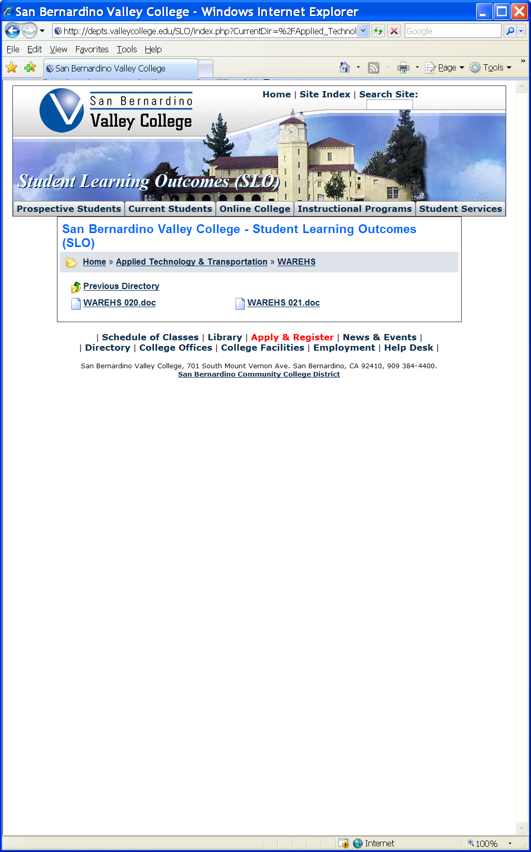

**The list above shows the courses that have SLOs on file with the Office of Instruction.**

If you have courses for which SLOs have not been developed, explain why.  What are your plans to remedy this?

|  |
| --- |
| SLO’s have been developed for all classes. |

**Attach your three-year plan for assessing SLOs.**

|  |  |  |  |  |  |
| --- | --- | --- | --- | --- | --- |
| **Transportation** | **SLOs Assessed** | **Total Courses** | **2009-Aug** | **2010-Sep** | **2011-Oct** |
| Rail | 0 | 4 | 2 | 1 | 1 |
| Refrigeration | 0 | 14 | 5 | 5 | 4 |
| Inspection | 0 | 12 | 4 | 4 | 4 |
| Diesel | 0 | 10 | 4 | 3 | 3 |
| Warehouse | 0 | 2 | 0 | 1 | 1 |

What progress has the program made in its three-year plan? Have you implemented any program changes based on assessment results?

|  |
| --- |
| SLO’s are on file with the Office of Instruction and specific assessments having been developed. The learning outcomes support the Institutional Core Competencies for critical thinking and communication. Specific assessments have been developed for each learning outcome. The assessments are easy to administer and evaluate. One example is in the warehouse lab whereby a student must process a purchase order from start to finish through the Warehouse Management Software system which will print out necessary business / legal transportation documents that verifies the work was completed properly and within industry standards. The learning outcomes are such that institutional core competencies such as critical thinking and communication are necessary to achieve the learning outcomes and successfully complete assignments that are used in assessment. With personnel turnover in leadership positions in the Department very little discernable progress toward assessment and implementation of program changes based on assessment has been made. Plans are to assess WAREHS 020 in September of 2010 and assess WAREHS 021 in October 2011. |

**Part III. Questions Related to Strategic Initiative: Institutional Effectiveness**

**Mission and Purpose**

What is the purpose of the program?

|  |
| --- |
| The Warehousing Department strives to support economic and workforce development by providing quality and up to date industry and community responsive training that prepares students and incumbents from the community for successful careers in their industry while meeting the Transportation Industry's growing needs for ready to work new employees and for advanced training for current employees.  The department offers industry developed learning outcomes and curriculum that has proven to be valuable to individuals seeking employment in the logistics industry sector. The base certificate program has clear learning outcomes and assessments to ensure instructors understand the goals of each class. The program is fully open to all members of the community and a key benefit of the program is to aid individuals in developing a career in an industry that according to Dr. John Husing, a leading Inland Empire Economist, pays above average wages and has a substantial career lattice that leads to substantial economic upward mobility. Additionally it has been found that the program has been used by students as their first “non-threatening” community college class and has lead to their pursuing further educational opportunities.  The program trains students with some of the latest warehousing technologies that are currently available in the industry. The program has been able to get much of the software and equipment donated from industry partners. One key element of technology is the program’s Warehousing Management Software (WMS) system that normally costs over $35,000 plus installation. Our students are able to work directly with industry typical technology and Subject Matter Experts and thus are much better prepared to succeed and advance in the workforce.  The department strives to support economic and workforce development by providing a gateway to vocational training. Open access to the program makes it accessible to a diverse student population. |

How does this purpose relate to the college mission?

|  |
| --- |
| *San Bernardino Valley College provides quality education and services that support a diverse community of learners.*  The program mission and purpose exemplifies our institutional mission in all areas. |

**Productivity**

Provide additional analysis and explanation of the productivity data and narrative in the EMP Summary, if needed.

|  |
| --- |
| Productivity in FTES has remained fairly steady from 04-05 to 07-08 with a drop into 08-09. This can be explained by a reduction in offered sections. There has been an 18% increase in WSCH per FTEF from 04-05 to 08-09 with several rises and decreases during the time frame. |

**Relevance and Currency, Articulation of Curriculum**

If applicable to your area, describe your curriculum by answering the following questions.

|  |  |  |  |  |
| --- | --- | --- | --- | --- |
| **Applied Technology, Transportation & Culinary Arts** | | | | |
| **WAREHOUSE** | | | | |
|  | **Course** | **Status** |  | **Next Review Date** |
|  | WAREHS020 Introduction to Warehouse Operations | Historical |  | 11/15/2008 |
|  | WAREHS020 Introduction to Warehouse Operations | Active |  | 05/11/2015 |
|  | WAREHS021 Forklift Operation and Certification | Historical |  | 11/15/2006 |
|  | WAREHS021 Forklift Operation and Certification | Active |  | 05/11/2015 |

The Content Review Summary from Curricunet indicates the programs current curriculum status. If curriculum is out of date, explain the circumstances surrounding the error and plans to remedy the discrepancy.

All curriculums are up to date

Articulation

|  |  |  |
| --- | --- | --- |
| List Courses above 100 where articulation is not occurring | With CSU | With UC |
| None of the class offerings are transfer eligible. No articulation agreements are needed |  |  |
|  |  |  |
|  |  |  |
|  |  |  |

Describe your plan to articulate these classes.

|  |
| --- |
| None required |

Currency

Review the last college catalogue data given below.

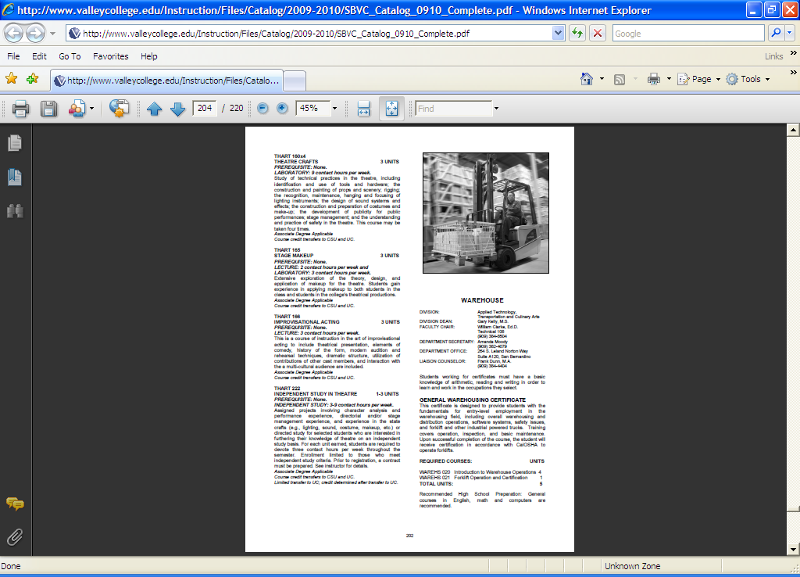

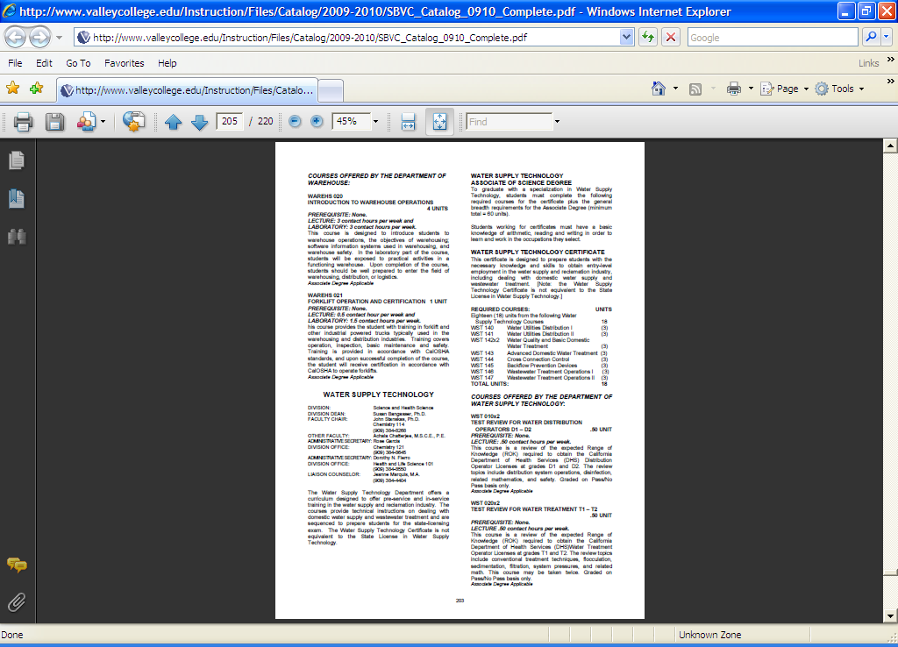

|  |  |
| --- | --- |
|  |  |

Which courses are no longer being offered? (Include Course # and Title of the Course)

|  |
| --- |
| The catalog is current in regards to course offerings. Faculty Chair data is out of date; will be updated in 2010/2011 catalog. |
|  |
|  |
|  |

**Planning**

What are the trends, external to the institution, impacting your student enrollment/service utilization? How will these trends impact program planning?

|  |
| --- |
| The department feels enrollment is strong. A trend that impacts the program is a lack of qualified part-time faculty. This is due to the fact that a person/s who meets the minimum qualifications as a instructor for the program are already employed and/or cannot commit to the time frame of the classes to ensure maximum student success. The program runs at capacity with two existing part time instructors. Planning is to expand if additional faculty can be located. Plans are in place to recruit additional faculty and partner with the Logistics Training Consortium of Southern California whereby schools plan to share adjunct faculty in a cooperative manner and thus increase overall regional training capacity. Planning for development of on-line classes and to further develop partnerships with warehousing industry in the Inland Empire. |

Accomplishments and Strengths

Referencing the narratives in the EMP Summary, provide any additional data or new information regarding the accomplishments of the program, if applicable. In what way does your planning address accomplishments and strengths in the program?

|  |
| --- |
| The warehousing program is located at the Transportation Center, 264 S. Leland Norton Way, which is part of what was formerly known as the Norton Air Force Base Facility. The Air base is now called the San Bernardino Airport and is operated by a consortium of neighboring cities. The warehousing program’s utilization of a logistics laboratory has set it apart from all other logistics training programs in the Southern California area. The use of laboratory exercises has greatly enhanced the ability for students to achieve learning outcomes since not only do they receive instruction in a lecture instructional format about logistics and its unique business cycle, but they must literally function in the roles of various logistics industry positions. An excellent example of how a key learning outcome is achieved and assessed is where each student, given a customer order to fulfill, must process both in the lab’s Warehouse Management System (WMS) system but also physically move the material, pack it, and load onto a truck for delivery. At the end of the exercise the students must have correct transportation documents printed off of the WMS to be assessed by the instructor (customer). In summary at the end of the program student performance and behavior must meet what employers and our advisory group has established as their own entry level employment requirements. Thus, students who achieve these learning outcomes will be ready to work in our employer partner companies if the student desires to do so and if other factors beyond the control of the college, such as felony convictions, are acceptable to particular employers. The location of the program at a major nexus of transportation, rail, road, and air transportation is a bonus by exposing the students to industry standards and methods in the classroom and in the industry. Planning has developed a successful marketing program in the format of brochures developed in conjunction with the graphics specialist at the district printing facility. The department plans to continue at the current level of sections and offerings since we are at capacity of the available resources.  1. The program continues to receive endowed scholarship fund donations from industry partners.  2. The program has received donation of $30,000+ WMS software at no cost.  3. The program is very visible in the community and has several strategic partnerships with multiple high schools, SBETA and County EDD, and several other community partners.  4.  The program is a member of the Logistics Training Consortium of Southern California and a partner in the multi million DOL grant currently managed through the state system office. |

Weaknesses

Referencing the narratives in the EMP Summary, provide any additional data or new information regarding planning for the program. In what way does your planning address trends and weaknesses in the program?

|  |
| --- |
| One of the primary issues the program faces is a lack of qualified adjunct faculty. Students typically are not applying for night classes, but rather day time classes because the target population is unemployed and underemployed. This group includes our partner high school students. Finding industry experienced, qualified individuals that can instruct during the day is difficult. Normally, qualified individuals are busy at work during the day, thus several potential daytime adjunct candidates are needed for the program.  The key trend we see is continued rapid growth in the need for logistics company employees. Employer demand will grow. The need to continue to grow the program to meet employer demand is also one of the department’s biggest challenges while maintaining program quality. Additionally working with consortiums that deliver a regional response to an industry with a state wide need per the EDD is a new trend and ensuring we work productively with the consortium in a manner that is beneficial to the College will be challenging. Keeping pace with other logistics trends in organizational design, compensations, new employee requisites and other areas of rapid change will require ongoing attention. We believe as active members in the Distribution Management Association, industry groups, and our Advisory Committee that the department is well connected to industry, experts, and employers, that will advise the department as to any additional, upcoming, or changing trends in the industry. |

**V. Questions Related to Strategic Initiative: Technology, Campus Climate and Partnerships.**

Describe how your program has addressed the strategic initiatives of technology, campus climate and/or partnerships.

|  |
| --- |
| The program has been involved in the National Transportation Summit, where SBVC is recognized nationally for its contribution to improving the education and employability for the diverse population in San Bernardino.  We anticipate the key training technology (Warehouse Management Software Computer System) we utilize is being updated to ensure the latest technology. This is in conjunction with our partnership with Advisory committee members who have provided initial deployment of this software. |